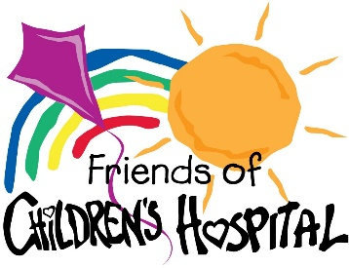
PRESS RELEASE

Contact:
Caitlin Foreman, Executive Director
Friends of Children’s Hospital
Phone: 601-502-5582
Email: friends@friendsofch.org

For Immediate Release
May 8, 2022

PAUL MOAK SUBARU DONATES $35,225 TO
FRIENDS OF CHILDREN’S HOSPITAL

Jackson, Miss. – May 8, 2023: Paul Moak Subaru donated $35,225 to Friends of Children’s Hospital as a result of the dealership’s annual holiday Subaru Share the Love® Event. Paul Moak Subaru has selected Friends of Children’s Hospital as its Subaru Share the Love® Event hometown charity partner for eight years and has donated over $122,000 to Friends of Children’s Hospital through the event.

The nationwide “Subaru Share the Love” initiative gives back to causes that touch the hearts of communities around the country. Over the 2022 holiday season, for each new Subaru purchased or leased at Paul Moak Subaru, Subaru of America donated $250 to Friends of Children’s Hospital. Doubling the financial support and impact, Paul Moak Subaru matched that donation 100 percent with an additional $250 donation.

“Paul Moak Subaru has impacted tens of thousands of children through their partnership with Friends that spans decades,” said Friends Executive Director Caitlin Foreman. “We are extremely grateful for their ongoing support, as well as the support of Subaru of America.”

Past donations have helped fund patient and family care projects, such as the Beads of Courage program for children with cancer, as well as capital projects, like the Kathy and Joe Sanderson Tower and Children's of Mississippi Center for Cancer and Blood Disorders, just to name a few.

"When we began participating in the Subaru Share the Love Event 15 years ago, we did not know we’d be embarking on a journey that would impact so many lives," said John Scarbrough, General Manager of Paul Moak Subaru. "We strive to be more than a car dealer and help make the world a better place all year round, but especially during the holiday season through the Subaru Share the Love® Event."

Since 2008, Subaru of America and its affiliate dealerships have donated more than $256 million to greater than 1,700 hometown charities through the Subaru Share the Love® Event.

About Friends of Children’s Hospital
Friends of Children’s Hospital, founded in 1989 by a group of dedicated volunteers from across the state, supports Mississippi’s only children’s hospital by driving fundraising, growing volunteerism and building awareness. Since its inception more than 30 years ago, the nonprofit organization has raised more than $45 million to purchase state-of-the-art equipment, construct new facilities and provide vitally important services for all pediatric patients. For more information about Friends of Children’s Hospital, please visit www.friendsofch.org or email friends@friendsofch.org.

###

